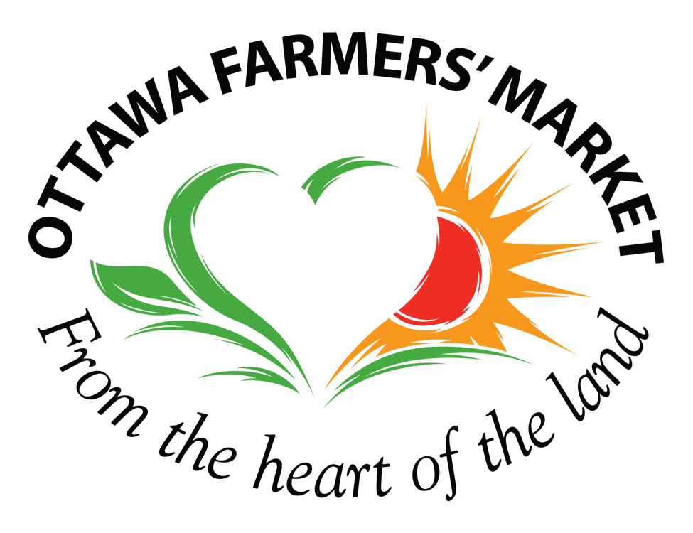

Ottawa Farmers’ Market Association

WAIVER OF LIABILITY

The waiver of liability is to be read and agreed to by all persons volunteering with the Ottawa Farmers’ Market Association.

No one will be allowed to volunteer without a agreeing to the Waiver of Liability.

I understand that by volunteering with the Ottawa Farmers’ Market Association I may be exposed to various risks of injury or harm. I understand and assume these risks and agree not to hold the Ottawa Farmers’ Market Association, its Board of Directors, employees, clients or vendors liable for any such injury or harm, or compensation for the same.

I also agree that I will not hold the Ottawa Farmers’ Market Association and its Board of Directors, employees, clients or vendors liable for any damage or injury to me or my property as a result of my volunteering at the Ottawa Farmers’ Market at Lansdowne Park, Byron Linear Park (Westboro), Ray Friel Centre (Orleans), Village Square Park (Stittsville) or the Riverview OC Transpo Park and Ride. I agree to be responsible for my behavior and to indemnify and hold harmless the Ottawa Farmers’ Market Association, its Board of Directors, employees, clients or vendors for any damages or liabilities arising out of my activities as a volunteer.

I also grant full permission for my name, likeness and image, including photographs and video recordings that are taken of me while engaged as a volunteer, to be used by the Ottawa Farmers’ Market Association for promotional purposes.

